**Project Management Plan**

**BIT Project**

10/01/2018

**Team Members**

Casey Smith

Mohammed Al Hashemi

Shaun Higgins

Mohammed Al Ofi

Document Control

**Change History**

|  |  |  |
| --- | --- | --- |
| **Revision** | **Change Date** | **Description of changes** |
| V1.0 | 10/01/2018 | Initial release |
|  |  |  |

**Document Storage**

This document is stored in the project’s SVN repository at: http://company.com/svn/project-name/docs/spmp.doc.

**Document Owner**

Casey Smith is responsible for developing and maintaining this document.

**Table of Contents**

**1 Overview... 4**

1.1 Purpose and Scope. 4

1.2 Goals and Objectives. 4

1.3 Project Deliverables. 5

1.4 Assumptions and Constraints. 5

1.5 Schedule and Budget Summary. 6

1.6 Success Criteria. 6

1.7 Evolution of the Project Plan.. 6

**2 Startup Plan.. 6**

2.1 Team Organization.. 6

2.2 Project Communications. 7

2.3 Tools. 7

**3 Work Plan.. 7**

3.1 Activities and Tasks. 7

3.2 Release Plan.. 8

3.3 Iteration Plans. 8

3.4 Budget. 8

**4 Control Plan.. 8**

4.1 Monitoring and Control 8

4.2 Metrics Collection.. 8

**5 Supporting Process Plans.. 8**

5.1 Risk Management Plan.. 8

5.2 Configuration Management Plan.. 8

5.3 Verification and Validation Plan.. 9

# **1 Overview**

## **1.1 Purpose and Scope**

The purpose of this network is to provide a 100 person medical doctor firm with multiple locations access to a new network that is currently being built. Employees for the firms should all have access to the company network and resources ( file servers, printers, etc ). Doctors have access to these resources, but also have a set of medical resources that only they and permitted users have access to ( servers with medical records, sensitive hardware etc ). At each of those locations, wifi will be provided for customers, that will not allow access to the network, but do allow access to the internet as a service.

We will also implement two different kinds of web filtering, one for staff and one for staff. Each filter is easily configurable if access to a restricted site is required.

## **1.2 Goals and Objectives**

Project goals:

1. Create a network for staff to use at all locations

2. Allow Customers to access the internet

Project objectives:

1. Allow Staff to access the company network and resources.

2. Apply modifiable web filtering for staff and customers

3. Allow Doctors access to restricted medical resources.

## **1.3 Project Deliverables**

The following items will be delivered to the customer on or before 12/04/2018:

1. Source code for both the client and server portions of the system.

2. System Administrators Manual

3. Test Plan

4. System test Cases

## **1.4 Assumptions and Constraints**

Assumptions:

1. Staff and Doctors will not attempt to use the network for anything malicious.

Constraints:

1. The network is currently limited to three physical locations

2. The Network must be ready by 12/04/2018.

## **1.5 Schedule and Budget Summary**

The initial project budget is $20,000.

09/19/2018 - Project Charter Approved  
09/21/2018 - Preliminary Requirements Complete  
09/28/2018 - Preliminary Project Plan Complete

10/01/2018 - Iteration #1 Complete  
10/10/2018 - Architecture Complete  
10/15/2018 - Iteration #2 Complete  
11/05/2018 - Iteration #3 Complete

11/09/2018 - Test Plan Complete

11/19/2018 - Iteration #4 Complete  
11/25/2018 - User Guide and System Administration Manual Complete

12/03/2018 - Iteration #5 Complete  
12/04/2018 - Product Released

## **1.6 Success Criteria**

* Total project cost does not exceed 20% of the post-requirements phase estimate.
* All high-priority use cases in the requirements specification are delivered before 12/01/2018

## **1.7 Evolution of the Project Plan**

Before the start of an iteration, the project plan will be updated to include a schedule of detailed tasks for the upcoming iteration. At the conclusion of an iteration, the project plan will be updated to include the actual effort for each completed task.

Risk mitigation efforts will be evaluated at the start of each iteration. Severe risks will be analyzed and added to the project plan as soon as they materialize.

# **2 Startup Plan**

## **2.1 Team Organization**

Project Manager: The project manager is responsible for creating the project plan (with input from those doing the work), managing risks, running the weekly team meeting and providing monthly status reports to senior management.

Developer(3): Developers are primary responsible for initial research and testing modules. They are also expected to take part in architecture planning and review meetings.

## **2.2 Project Communications**

Slack will be the main platform for communications and file management with github holding the end result of each step. Trello will be used as a project management tool.

## **2.3 Tools**

· Networking Emulator – GNS3

# **3 Work Plan**

## **3.1 Activities and Tasks**

A work breakdown structure is an excellent tool for identifying a complete list of tasks.Every projects have tasks and activities that each one of the tasks and activities have a specific goal or target to reach.Depending on the needs of the project, some or all of the following attributes will be recorded for each task:

Example of a task:

* Task name: web traffic filtering.
* Task Description: Research about the different kind of web traffic filtering.
* Owner: Team 11
* Effort estimate: 8 hours
* Actual effort: 5 hours
* Planned start and stop dates: 09/29/18 to 10/01/18
* Actual start and stop dates:09/29/18 to 10/01/18
* Dependencies among other tasks: Finish to Start

## **3.2 Release Plan**

A release plan is a plan for the entire project which can be fixed and changed later. In other words, a release plan is specifies the timing of iterations and a rough allocation of product features to iterations and it is one per project. So, the release plan is combination of number of iterations, The release plan for this project will be divided by the iterations. Therefore, after number of Iteration will release the plan or the product to test it or to change it.Then, will continue to work on the next Iteration until we have a complete release of the product.

The BIT project release plan will be one plan that will be representing the product at the end of the semester.

## **3.3 Iteration Plans**

An iteration plan is a short-term fine-grained plan that shows the tasks to be completed during an iteration. In other words, an iteration which specify the detailed tasks for an iteration, and in some cases an assignment of tasks to individuals. Therefore, In this project we have five Iterations that we will be working on. Every things that relate for each Iteration is posted in the Excel cheat that contain the role, Estimate time, Effort for each role and the dates of the Iterations have already set by the professor.

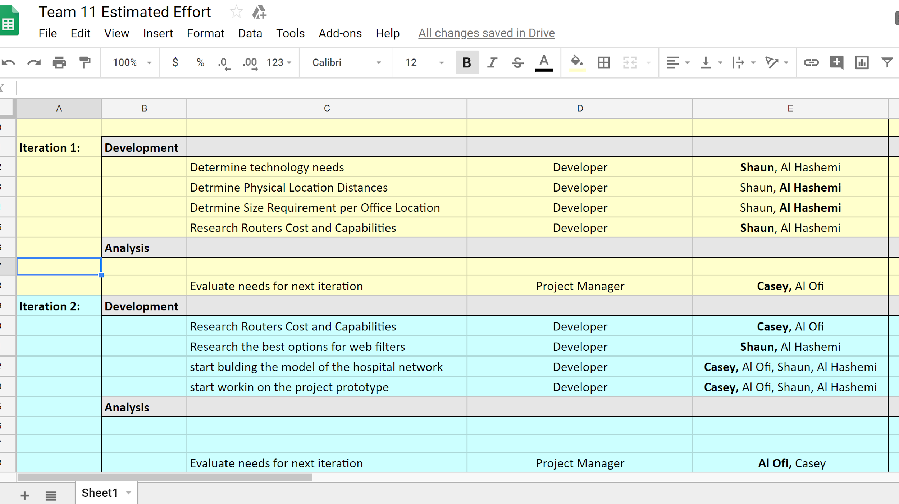

## **3.4 Budget**

The project budget is the projected cost of the project as a function of time. We have assumed a great deal of money for this project approximately more then $20,000 that I believe will be enough to complete the project. In addition, we believe the budget will go up or down depends on the material or the products that we are going to use in this project.

# **4 Control Plan**

## **4.1 Monitoring and Control**

Weekly - Team meeting, Project participants report status, progress and potential problems.

09/17/2018 - iteration 1 begins

09/19/2018 - project charter submission

09/21/2018 – requirements document baselined submission.

10/01/2018 – iteration 1 closeout, iteration 2 begins, and project plan submission.

10/02/2018- 11/04/2018 – working with team in iteration 3, technical prototype, checking project status and architecture, and iteration 3 closeout.

11/05/2018 – 11/25/2018- working on iteration 4 and 5 from begin to closeout, and testing project plan. Also, building user and system guide.

12/10/2018 – final, when the project is finished and ready to be out for service

## **4.2 Project Measurements**

Product and process measures support project management and estimation by analogy. At the beginning of a project, estimates are made for product size, project cost and delivery dates. During a project, progress is tracked with measures of actual effort, integrated lines of code and actual expenditures. Keeping track of estimates and actuals during a project helps to calibrate whatever technique is being used to make estimates. Storing project performance data on completed projects provides a rich source of data for estimating future projects.

|  |  |  |
| --- | --- | --- |
| **Phase** | **Measurement** | **Source** |
| Release Planning | Team met in order to plan the project and finishing up the requirement documents. | G11 |
| Iteration Planning | All 4 team members work in different parts on iteration to complete it physically and documentary. | G11 |
| Iteration Closeout | For each iteration, team meet in order to keep track of what we done so far and what we could not complete. Then, team submits the summary document of effort and achievements. | G11 |
| System Test | After completing iteration#3 , we will test the system, and report the result. | G11 |
| Project Closeout | When we will finish building the project , a presentation of result, issue, and performance will be provided. | G11 |
| Ongoing | This part will be updated depends on finding an opportunity for ongoing process. | G11 |

# **5 Supporting Process Plans**

## **5.1 Risk Management Plan**

Identify technical and managerial risks. Prioritize risks. Consider the probability of each risk turning into a problem and the likely consequences. For the highest priority risks, what actions will be taken to minimize the probability of the risk turning into a problem and the resulting consequences? What are the contingency plans for selected risks that do become a problem? Identify processes for monitoring risks and updating the risk management plan.

Risks to be aware of:

1. DoS attacks- Inevitable probability, hackers could use DoS attacks to halt hospital operation in exchange for ransom which could be devastating to the hospitals financial status but more importantly the lives of it’s patients. Combating this could incorporate many factors such as having all of the necessary firewalls in place and a security specialist who has up to date knowledge with software and can be available with very short notice.
2. Customer data compromise- Medium probability, Customers rely on our security to guard their financial and confidential health records that could be devastating if used against them. This means that our database has to be secure and extra measures need to be taken such as authentication protocols so the only one who has access to these records are doctors.
3. Insufficient personnel/ Spiteful employees- Low probability, an employee who accidentally or intentionally erased medical records could have a major impact on the company. This could be solved by training and team-building exercises to improve competence and business morale.
4. Poor design architecture- Low probability, getting to the end of a project and realizing that your network cannot handle the stress of its required functions or does not fit customers vision can be horrible. To counter this the project manager should have productive and periodic contact with the customer to ensure all requirements are being met.
5. Unforeseen requirements/ unrealistic schedule- Low probability, this can greatly hamper the quality of a project and may determine whether it gets released or not. Contingencies for this would be implementing an agile methodology and clear iteration plans so that everyone on the team knows what is required per iteration and can have time to adapt future iterations for new requirements.
6. Catastrophic natural disaster such as a fire- Low probability, most businesses would not expect their downfall to be a natural disaster but with enough businesses it will eventually happen to someone. There should be backup drives connecting the 3 businesses where data will be directed to another building.

## **5.2 Configuration Management Plan**

Configuration management plans for this document and other baselined work products including review procedures and change management procedures.

1. All work products will be stored in GitHub

2. The naming convention for documents will be: NNN-VVV.suffix where NNN is a mnemonic that reflects the function of the document, VVV is a 3 digit version number, and 'suffix' is the standard/normal suffix for the document type. For example, the second version of the requirements document created as a Microsoft Word document might be labeled: REQ-002.doc.

3. All project (work products) items (documents, source code, test cases, program data, test data, etc) will be stored in the CVS repository but not all will be under change control (subject to formal change control procedures.) Only the system requirements, project plan and source code will be baselined and under configuration control.

4. Items that are subject to change control will be considered baselined after a group review at the end of the life cycle phase during which they are created. Baselined here means that the product has undergone a formal review and can only be changed through the prescribed change control procedures.

5. The change control procedure once a product is baselined is: (1) anyone wanting to make a change to a baselined item sends an email to the rest of the group describing the change, reason for the change, expected impact, and timeline for integrating the change. (2) if no one responds to the group within 2 days with a reason for why the change request shouldn't be permitted, it will be considered accepted and the person proposing the change may proceed with the change. If anyone does object to the change, the reason for objecting will be discussed at a meeting where everyone is invited to attend and voice their opinion. At the end of the meeting a democratic vote will be held to decide whether or not the change should be allowed.

6. Including a change history with all documents is encouraged but only required for baselined documents. The change history should be at the front of the work item and include: (1) the name of the person making the change, (2) brief description of what has changed, (3) reason for the change, and (4) the date the change was integrated.

## **5.3 Verification and Validation Plan**

The verification and validation plan defines what actions are being taken to assure the quality of the development process and resulting software products.

Our verification plan should take note of:

1. Whether our hospitals can communicate with each other

2. Does the network provide web filtering and access to the internet

Our validation plan should check if our project:

1. Meets our budget
2. Give customers access to internet but not network
3. Can employees access to some internet and network devices
4. Do doctors have correct authentication protocol for private information and hardware on the network
5. Three Locations shared on network
6. Designated corporate office as one location